**Memory:**

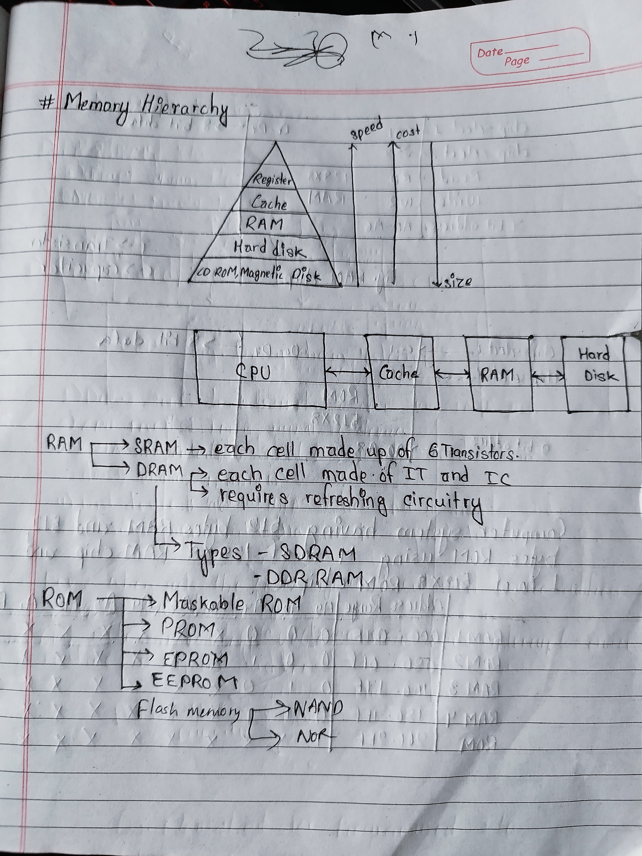

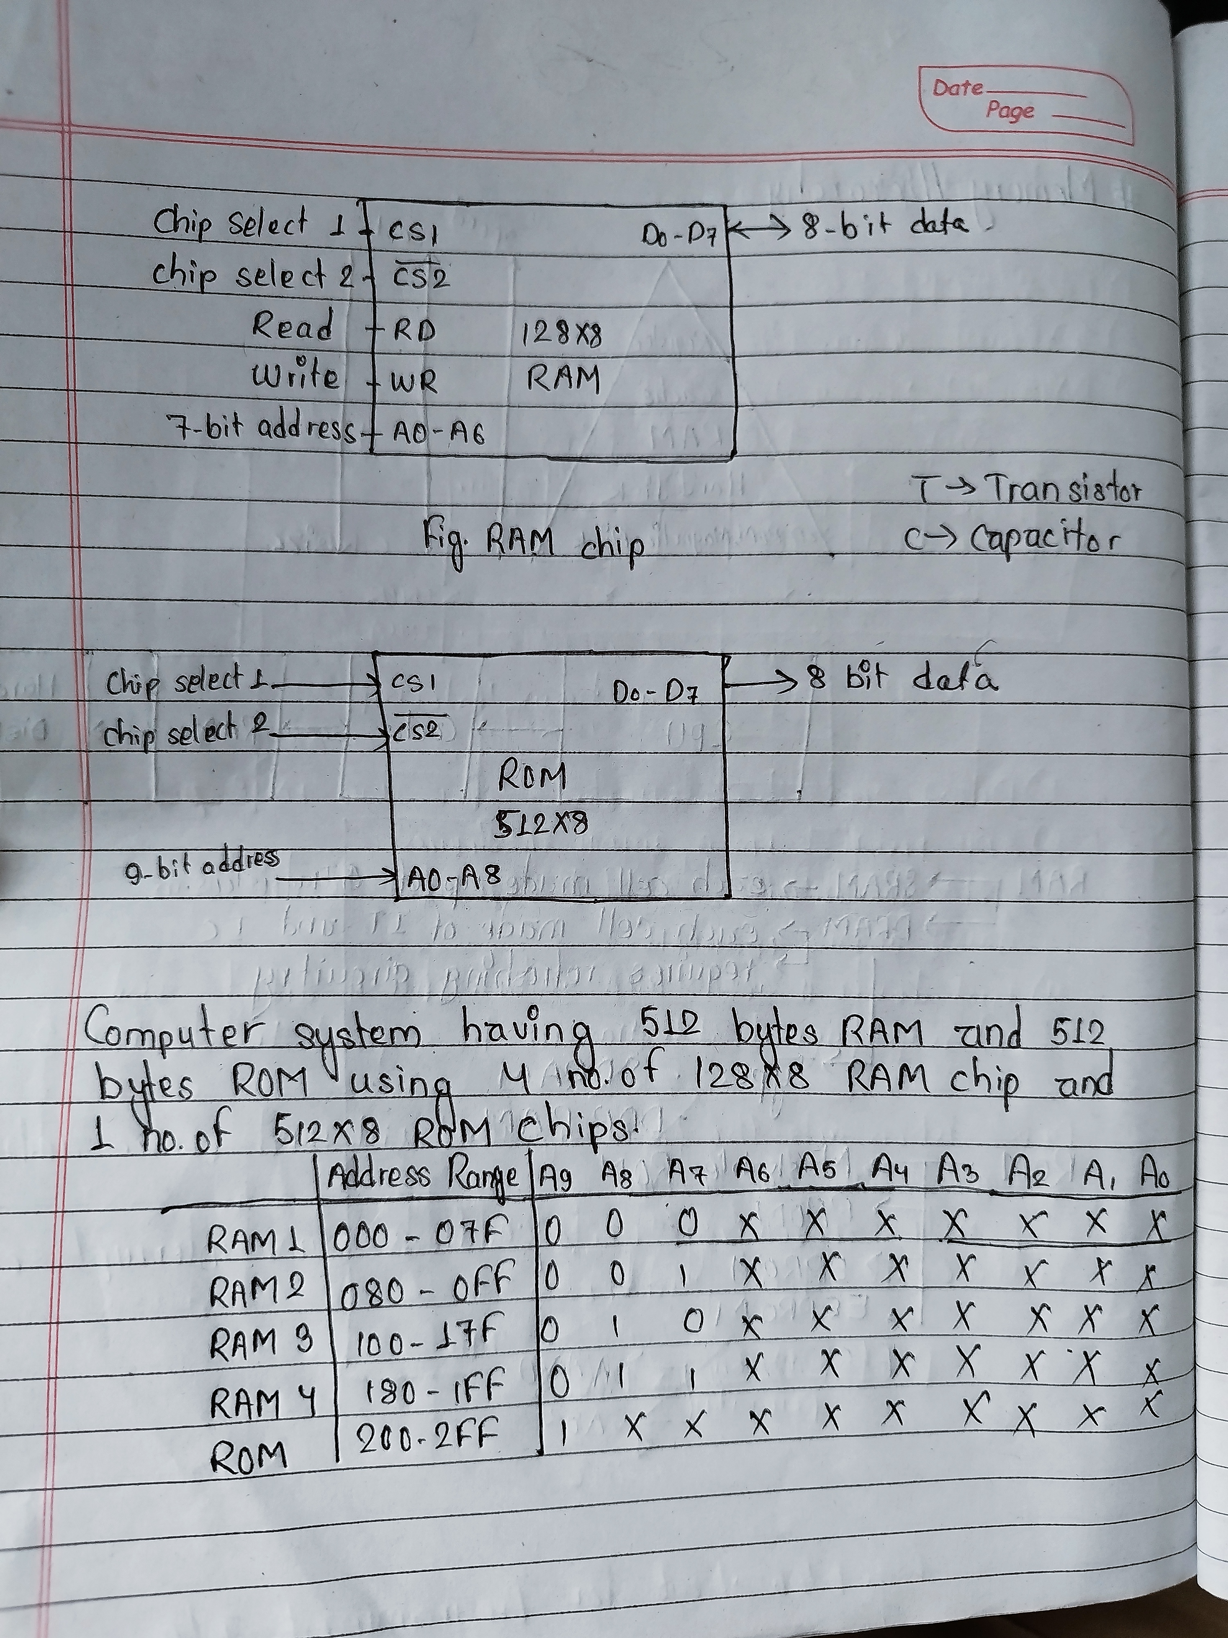

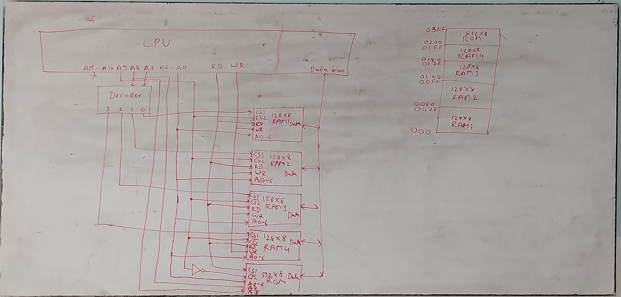

Cache:

It is the high speed memory inside the CPU used for quick access to frequently used data.

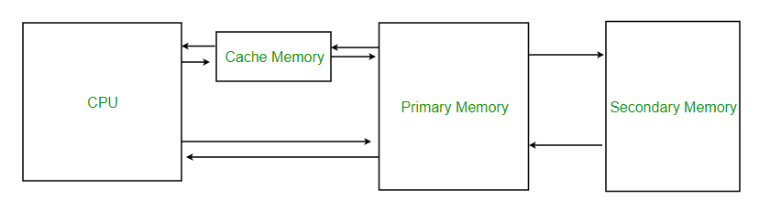Principle of Locality of Reference:

Locality of reference, also known as the principle of locality, is the tendency of a processor to access the same set of memory locations repetitively over a short period of time.

Cache Mapping:

Cache mapping refers to a technique using which the content present in the main memory is brought into the memory of the cache.

There are three different types of mapping used for the purpose of cache memory which is as follows:

* Direct Mapping
* Associative Mapping
* Set-Associative Mapping

Direct Mapping:

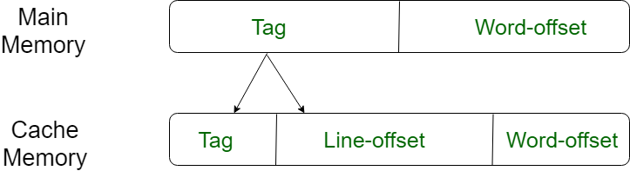

The simplest technique, known as direct mapping, maps each block of main memory into only one possible cache line. or In Direct mapping, assign each memory block to a specific line in the cache. If a line is previously taken up by a memory block when a new block needs to be loaded, the old block is trashed. An address space is split into two parts index field and a tag field. The cache is used to store the tag field whereas the rest is stored in the main memory. Direct mapping`s performance is directly proportional to the Hit ratio.

i = j mod m

where

i = cache line number

j = main memory block number

m = number of lines in the cache

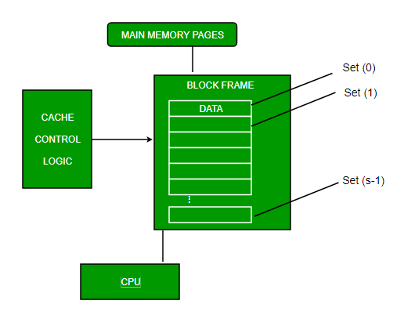

Associative Mapping:

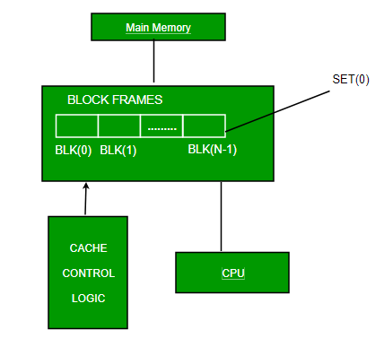

In this type of mapping, associative memory is used to store the content and addresses of the memory word. Any block can go into any line of the cache. This means that the word id bits are used to identify which word in the block is needed, but the tag becomes all of the remaining bits. This enables the placement of any word at any place in the cache memory. It is considered to be the fastest and most flexible mapping form. In associative mapping, the index bits are zero.

Set-Associative Mapping:

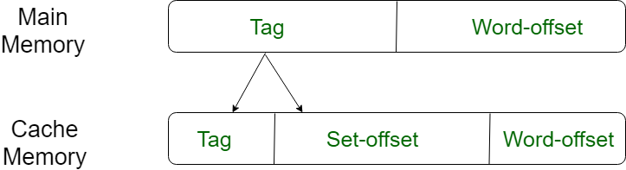

This form of mapping is an enhanced form of direct mapping where the drawbacks of direct mapping are removed. Set associative addresses the problem of possible thrashing in the direct mapping method. It does this by saying that instead of having exactly one line that a block can map to in the cache, we will group a few lines together creating a ***set***. Then a block in memory can map to any one of the lines of a specific set. Set-associative mapping allows each word that is present in the cache can have two or more words in the main memory for the same index address. Set associative cache mapping combines the best of direct and associative cache mapping techniques. In set associative mapping the index bits are given by the set offset bits. In this case, the cache consists of a number of sets, each of which consists of a number of lines.

Relationships in the Set-Associative Mapping can be defined as:

m = v * k

i= j mod v

where

i = cache set number

j = main memory block number

v = number of sets

m = number of lines in the cache number of sets

k = number of lines in each set

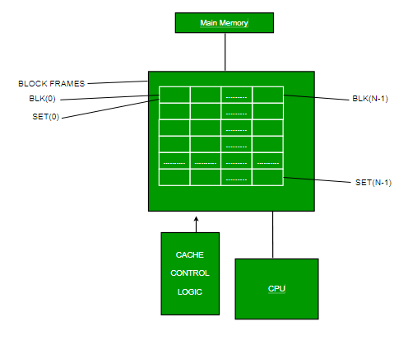

**Cache Replacement Policy:**

Whenever there is a cache miss, replacement of block is needed to be done. In direct mapping technique, blocks are replaced in specific location. In associative and set-associative mapping block can be placed in any line of cache/within set. So, we need replacement policy to determine which block to replace.

The policies are:

1. FIFO→ Whichever block is first placed is replaced by new block.
2. LFU→ Least Frequently Used block which is least used is replaced by new block.
3. Random→ random blocks are replaced by new blocks.
4. LRU→ Last Recently Used block is replaced by new block.

**Cache Write Policy:**

1. Write Back→ CPU writes to cache only. Written cache entry are marked dirty. Dirty entry are updated in memory when necessary.
2. Write through→ Whenever CPU writes to cache, data is written to memory.

**Associative Memory:**

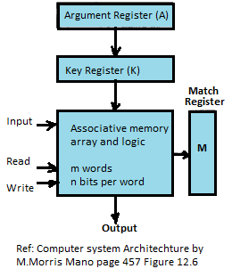

**Associative memory** is also known as content addressable memory (CAM) or associative storage or associative array. It is a special type of memory that is optimized for performing searches through data, as opposed to providing a simple direct access to the data based on the address. When a word is written in CAM, address is not given, memory is capable of finding an empty space to store the word. When a word is to be read form CAM, the content of word or part of the word is specified. Memory locates all words which match the specified content and marks them for reading.

